SCHOOL GROWTH PLAN FOR gibsons elementary 2022-2023
Our Story and Journey

Through the four strands of the braid, we learn together as a school community.

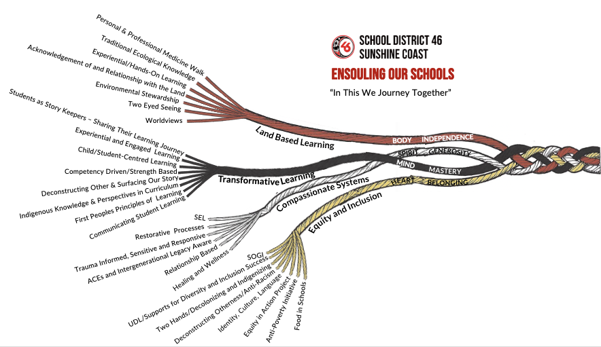

DEMOGRAPHICS
- 366 students, K-7; 17 divisions; over 50 staff members
- 73 students with Ministry Designations; 52 students identify as Indigenous; 34 ELL students
- Strongstart, Seamless Day, Just B4 program, YMCA Daycare; a hub for Early Learning
- Community School Coordinator—Kidz Club, multiple programs, Food Security
- Situated close to walking trails, hikes and beaches

VISION
- We learn today to succeed tomorrow (will revisit)
VALUEs
- Relationships, connections, community
- Trust, respect
- Gratitude, generosity
- Positivity, growth mindset
- Achievement, growth
All to support the growth of the whole child.
(We will refine our values September 2023)

ENSOULING OUR SCHOOLS: COMPASSIONATE SYSTEMS
- Zones of Regulation are used in many classrooms
- Restorative practices: office referrals—restorative approach (repair)
- Trauma informed instruction (pro-d for whole staff)
- Strength-based focus vs. deficit focus
- Start each staff meeting with WWW (what went well) to create a positive generative social field

ENSOULING OUR SCHOOLS: TRANSFORMATIVE LEARNING
- What inspires transformative learning? Experiential learning, connections, communication, accountability, perseverance, resiliency, collaboration, openness
- First Peoples Principles of Learning: foundational guidelines we use to reflect on our teaching practice and develop with our students to engage in authentic Indigenous learning experiences
- Communicating Student Learning: staff are engaged and committed to communicating through strength-based descriptive feedback to support all learners

ENSOULING OUR SCHOOLS: EQUITY AND INCLUSION
- One piece of the equity scan gave us the opportunity to hear the voices of Indigenous students: feel supported at school, like school, but some feel that Indigenous Ways of Knowing and Being are not always explicitly part of their learning (learning survey questions)
- We welcome and include all students to take part in our breakfast, lunch or after school snack programs
- We celebrate the multi-cultural community we are so fortunate to be a part of
- We support and respect all of our community, regardless of race, religion, gender, gender identity or sexual orientation

ENSOULING OUR SCHOOLS: LAND BASED LEARNING
- More classes are taking advantage of the forest and walking trails that surround our school grounds
- Our community garden has had a rejuvenation! Inspired by a classroom teacher, a team of educators now spend time in the garden with their students—planting, tending, harvesting, learning
- Many classrooms hike the nearby trails and beaches
- Staff members are taking turns acknowledging the lands we are on at staff meetings, circles in classrooms

CURIOUS EVIDENCE/DATA
We are curious if our learners’ academic achievement (literacy focus) will improve with increased resiliency.
- safe learning environment…trust…resiliency…growth mindset…improved results

Satellite Data:
2022 FSA—Grade 4 Literacy |  |  | 2022 FSA—Grade 7 Literacy
94 % participation rate |  |  | 88% participation rate
Emerging | Ontrack | Extending | Emerging | Ontrack | Extending
24% | 69% | 7% | 17% | 83% | 0%

Map Data:
2022 Grade 4 Learning Survey
Grade 4 Learning Survey |  | Grade 7 Learning Survey
84% | I am happy at school.
86% | Do you feel welcome at school? | 91% | Do you feel welcome at school?
83% | At school, are you learning about Indigenous Peoples? | 87% | At school, are you learning about Indigenous Peoples?
88% | Do you feel safe at school? | 93% | Do you feel safe at school?
77% | How many adults do you think care about you? (more than 1) | 70% | How many adults do you think care about you? (more than 1)
*sometimes/always
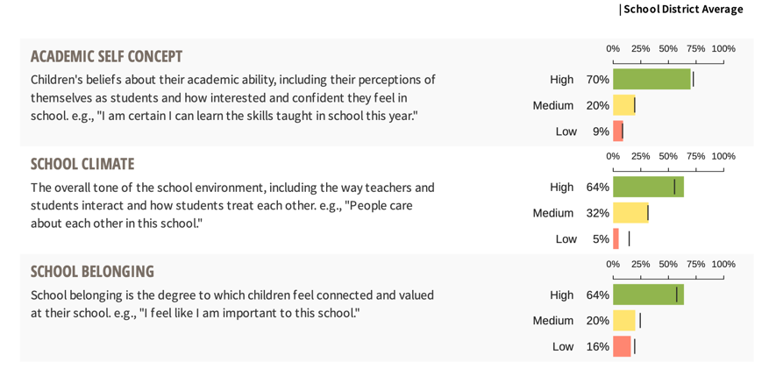

2023 Grade 5 MDI
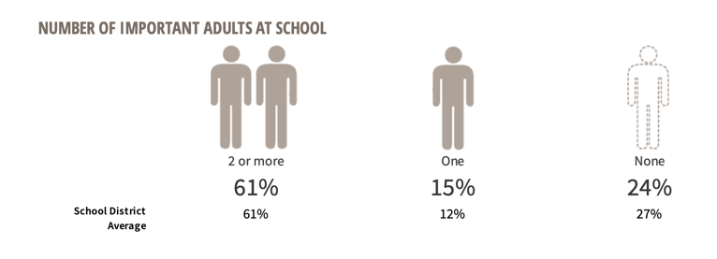

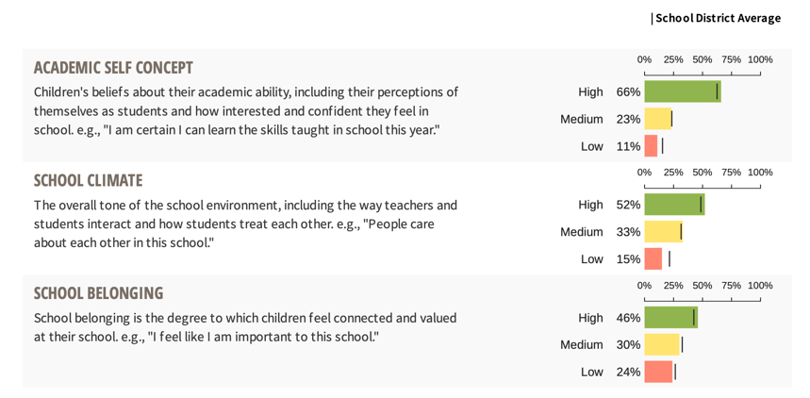
2023 Grade 6 MDI
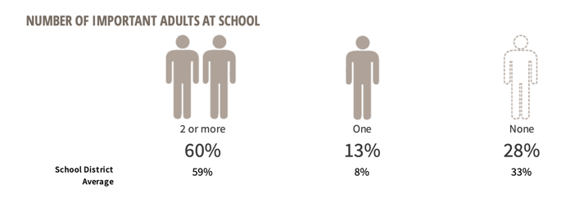

Street Data:
Equity Scan: Most students surveyed felt that they had good relationships with adults, liked school and felt safe at school. However, some did not report that they were learning a lot about Indigenous Peoples. (learning survey questions)

NEXT STEPS
- Professional Learning: Trauma Informed Instruction (May Pro-D day)
- Compassionate Systems Leadership Training with staff (Sept 2023)
- Collaborate regularly: how do we build connections with students? How are we creating an environment for students to feel safe to take risks? How do we encourage students to persevere with a task when they ‘feel’ it is too challenging? How do we instill a growth mindset in all our learners?
- Update Code of Conduct
- Encourage more school-wide activities to build team, connection and community
- Refine growth plan goal
- Staff meet with individual students to gather more street data (questions) to have a larger data set
- Plan: how to make Indigenous learning more visible for students

